# Image Processing

## Adaptive binarization and cropping of an Image

## Assignment Report

### Under the guidance of:

### Prof. Dr.-Ing. Milan Gnjatovi´c

Presented by:

Rudradeep Palit

11038108

Purpose:

The main purpose of the program is to perform adaptive binarization and cropping of an input image. Adaptive binarization is a technique used to convert a grayscale image into a binary image, where each pixel is classified as either black or white based on a local threshold computed around that pixel.

Key Features and flowchart:

Loading Image: The program loads an image file from the specified file path.

Grayscale Conversion: It converts the loaded image into a grayscale image, where each pixel's intensity is represented by a single channel.

Adaptive Binarization: The grayscale image undergoes adaptive binarization, where each pixel's intensity is compared with a dynamically calculated threshold based on the local pixel neighbourhood. Pixels with intensities below the threshold are set to black, and those above are set to white.

Cropping: The program identifies the object or region of interest in the binarized image and performs both vertical and horizontal cropping to extract the object from the background.

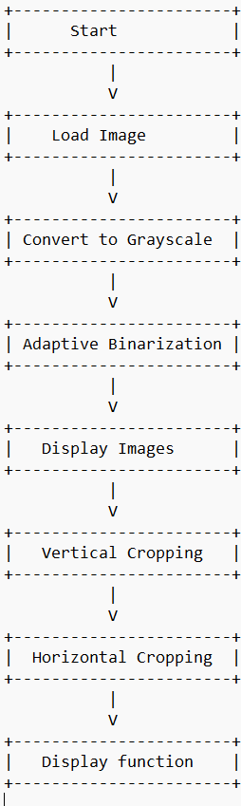

Code Components:

setup() Function: Initializes the program, loads the input image, converts it to grayscale, performs adaptive binarization, and displays the original, grayscale, and binarized images.

toGrayscale() Function: Converts the input image to grayscale using the luminance formula.

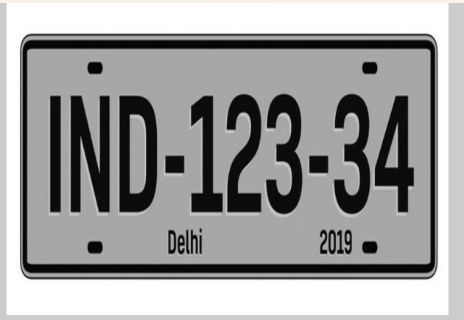

adaptiveBinarization() Function: Implements the adaptive binarization technique by calculating local thresholds for each pixel based on its neighbourhood and binarizing the image accordingly.

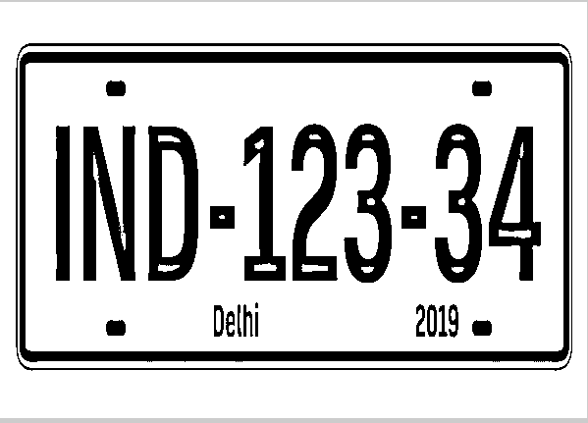

croppingVertical() and croppingHorizontal() Functions: Identify and crop the object vertically and horizontally from the binarized image, respectively.

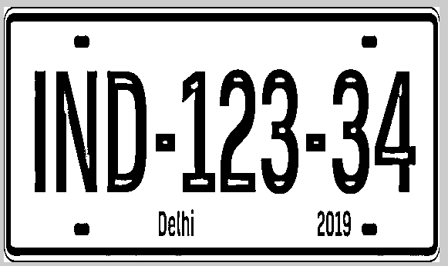

Parameters:

windowSize: Defines the size of the local neighbourhood used for calculating the adaptive threshold. I have assumed it to be 20 for shorter program run time.

scaleFactor: Determines the scaling factor applied to the average intensity to adjust the threshold for binarization. I have assumed it to be 0.7 because with this binarization becomes more sensitive to dark areas, enhancing object detection accuracy in images with low light or darker objects.

Output:

The program displays the original input image, its grayscale version, the binarized image, and the vertically and horizontally cropped images extracted from the binarized image.

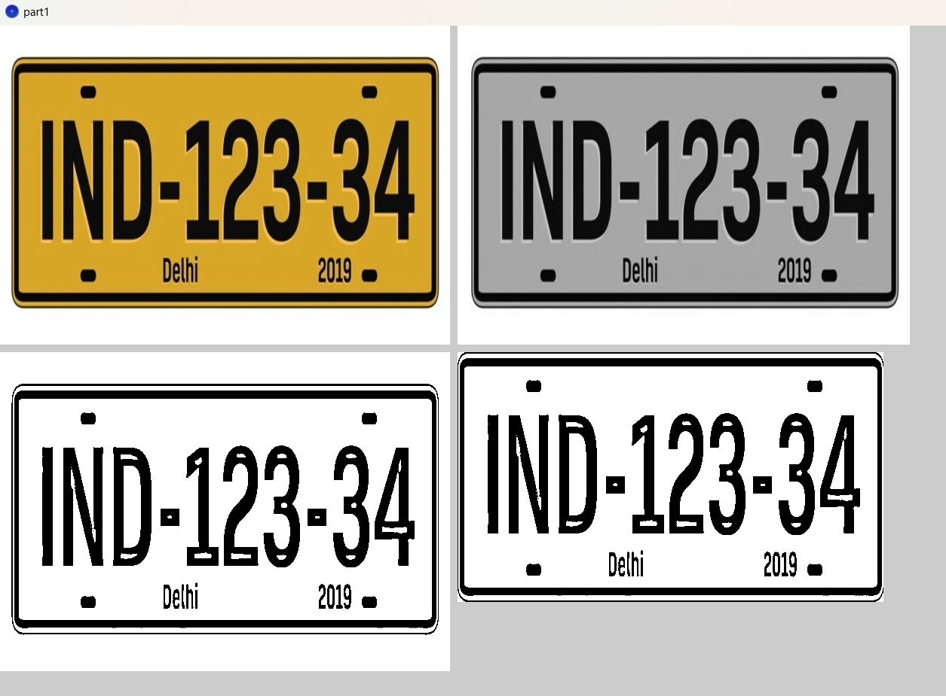

Conclusion:

In summary, the program shows how to improve image clarity and extract specific objects. It's a valuable tool for analysing images and isolating objects for further study or processing.

Sources:

* <https://homepages.inf.ed.ac.uk/rbf/HIPR2/flatjavasrc/AdapThresh.java>
* Kapur JN, Sahoo PK, Wong AKC (1985) A new method for gray-level picture thresholding

using the entropy of the histogram, Computer Vision, Graphics, and Image

Processing, Volume 29, Issue 3, pp. 273–285.

* http://gnjatovic.info/imageprocessing/ip.code.snippets.txt